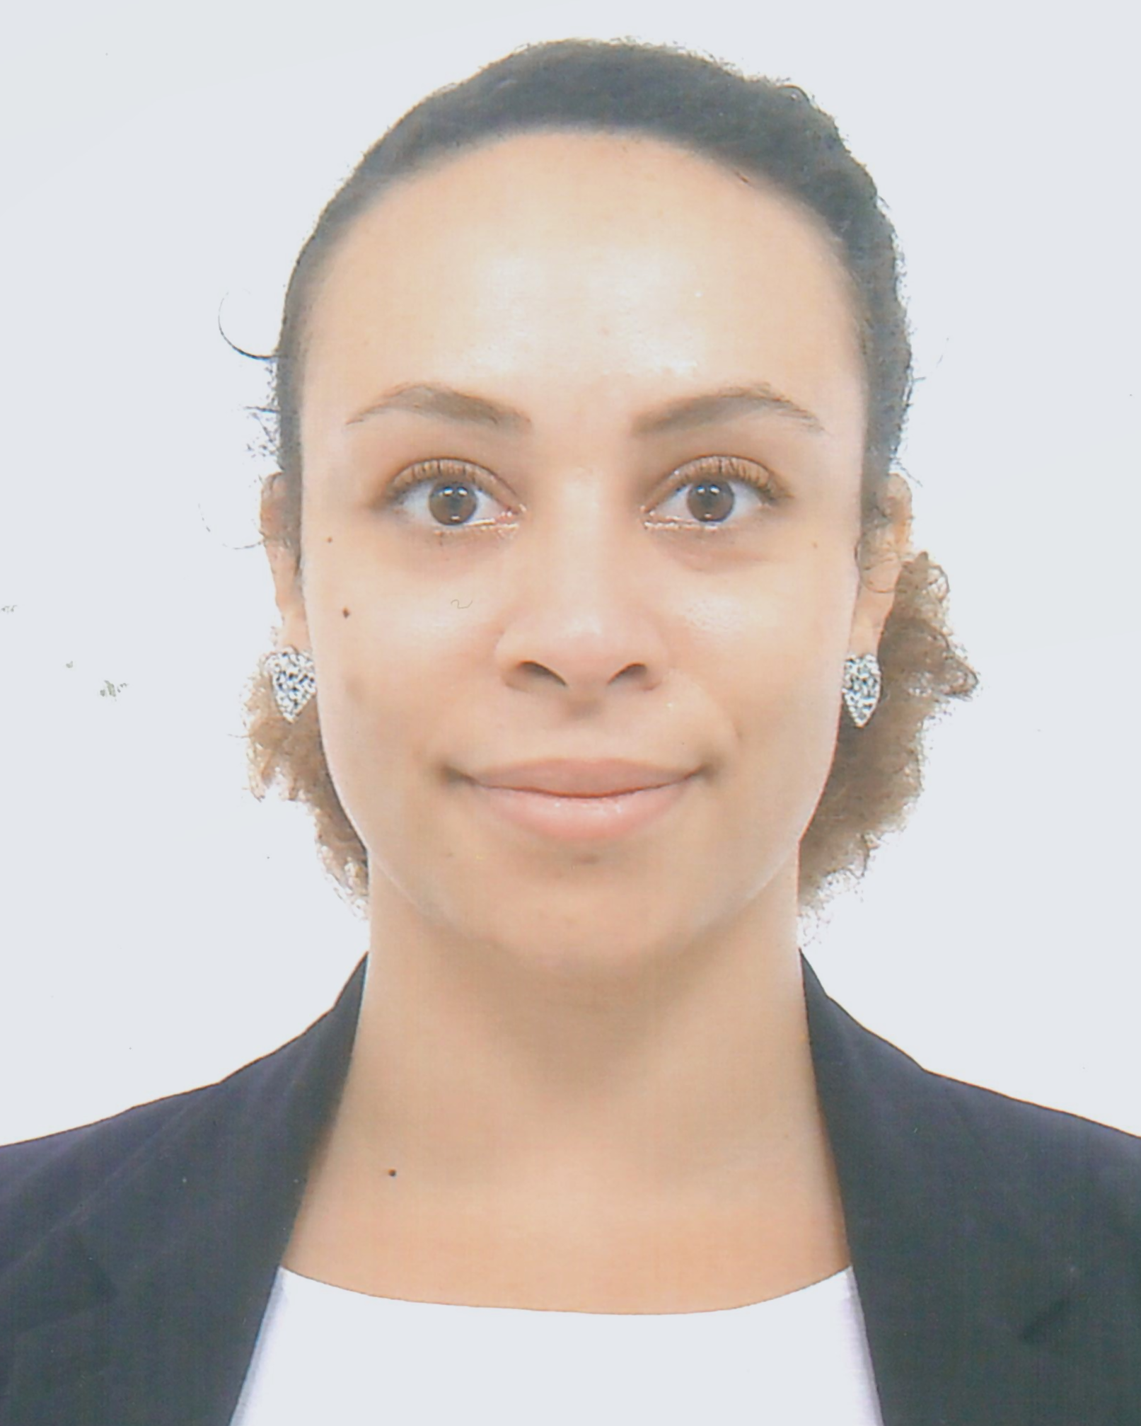
WORK EXPERIENCE
Senior Native English Teacher Since September 2018
CCC HK Chi to Church Kei Pok Kindergarten – Tseung Kwan O, HONG KONG
- Created engaging and interactive educational material for K1-K3 students. Taught phonics through Letterland.
- Worked in close collaboration with local teachers in creating and organizing extracurricular events.
- Took charge in training new NETs and helping them with their questions concerning the school’s curriculum and organization.

Play group teacher January 2019 - January 2020
NMS Lutheran Kindergarten – Kowloon Tong, HONG KONG
- Used play-based activities, storytelling, crafts projects and music to help toddlers become more familiar with English and understand simple instructions.
- Cooperated with parents to build a safe and joyful environment for their children to thrive in and socialize.

K2 Class Teacher September 2016 - July 2018
NMS Lutheran Kindergarten – Kowloon Tong, HONG KONG
- Planned and implemented English language and Jolly Phonics activities for two K2 classes.
- Monitored students’ progress and completed their evaluations and portfolios.
- Handled monthly written communication with parents.

Private French tutor April 2017 - January 2020
Multiple districts – HONG KONG

F&B French cultural representative February 2014 - February 2015
Les Chefs de France (EPCOT Park; Walt Disney World) –Orlando, FL, USA

2/F, Flat E LENA RINNA
68, Hollywood road
Sheung Wan Native English Teacher

Mobile: 59940150
Whats App: +33652517027
E-mail: lena.rinna@gmail.com

EDUCATION
2020 180-hour Online TEFL Certification. Added focus on Grammar and EFL for young children.

Université de la Sorbonne-Nouvelle Paris 3 2013
Paris – FRANCE Bachelor’s degree in Foreign Languages (English & Spanish) applied to Economics and Law.

Lycée International Honoré de Balzac 2009
Paris – FRANCE Baccalauréat (French High School Diploma) in Economics & Social Sciences.
European English class (advanced English). Visual Arts Minor.

STRENGTHS SKILLS
- Passionate about teaching English: Bilingual proficiency
- Creative French: Native language
- Team player Spanish: Conversational
- Eager to learn IT: Proficient with Microsoft office
- Multicultural Background Competent with interactive smart boards

Te

IT I

INTERESTS
Travel Work experiences in Spain and the USA; various trips to Europe, Mexico, the Caribbean,
East and South-East Asia.
Dance Hip-Hop, Ragga-Dancehall, Salsa and Bachata dance student since 2006.

